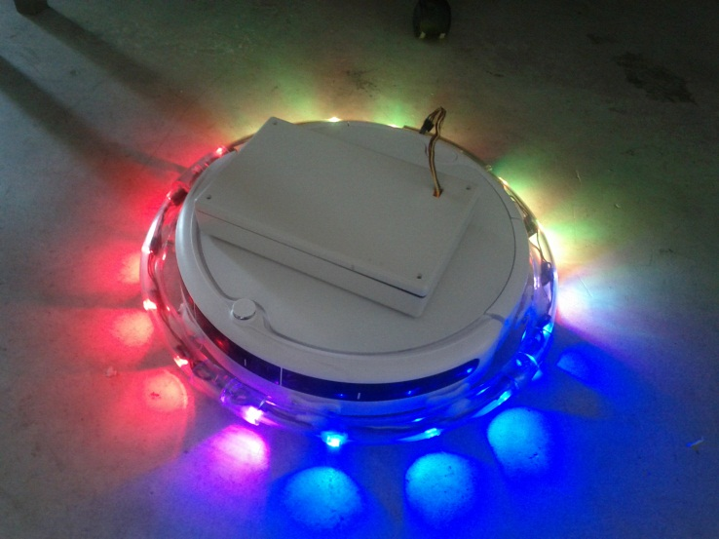We have placed a robotic vacuum cleaner in this shop that displays colours on the floor. The goal of this research is to study how our robot impacts public environments. An on-site researcher will be informally taking notes on how people interact with the robot. No confidential information will be recorded in these notes. If you wish to be excluded from observation, please inform the experimenter and they will happily accommodate you. The robot itself is extremely safe and poses no physical risk beyond that of a standard vacuum cleaner.

While the robot is cleaning the floor, you can control which colours the robot displays by going to [**www.**](http://www.robotreporter.com/)**colourbot.com** using your cell phone or laptop. No personal information will be recorded, with full details presented on-line before you participate. For on-line participation, you will receive a $2 gift certificate (on your first, third, and seventh uses with a limit of one per 2 hours) for your time.

If you have some free time, we encourage you to approach the on-site researcher to answer a short 10-20 minute questionnaire. By answering these questions, you will help us build a broader understanding on how we can use robots in public spaces in the future. To show our appreciation you will receive a $5.00 certificate to be used at this establishment.

No confidential information will be included or in any way associated with the data collected in the study. All data will be stored in a locked office and will be destroyed after the results are published.

If you have any concerns or would like more detail about something mentioned here, or information not included here, you should feel free to ask the on site researcher, or contact the numbers below.

This research has been approved by the Joint‐Faculty Research Ethics Board**.** If you have any concerns or complaints about this project you may contact Dr. James Young at 204-474‐6791 or the Human Ethics Secretariat at 204-474‐7122.